  - Explainable methods for financial technologies

Table of Contents
1. Introduction 2
2. Problem definition 2
3. Our solution / Product Prototype 2
4. Methodology 3
4.1 Data explanation 3
Exploratory Data Analysis: 5
4.2. Data Pre-processing: 7
4.2.1 Error Detection 7
4.2.2. Encoding 7
4.2.3. Splitting Data 7
4.3. Classification 7
4.3.1. Extreme Gradient Boosting (XGBoost) 7
4.3.2. Decision Tree (DT) 8
4.3.3. Support Vector Machine (SVM) 8
4.4. Explainable AI 8
4.4.1. Global Explanation 9
4.4.2. Local instance-based 10
4.4.3. Local feature-based 10
4.5. Front-end Development 11
5. Findings 11
5.1. Model Performance: 11
5.2. Global Explanation 12
5.3. Local instance-based 13
5.4. Local feature-based 14
6. Impact and Significance of Results 14
7. Project Management 15
8. Ethical consideration 17
8. Conclusion & Future Development 18
References 19

1. Introduction
This report provides background to the project, the methodology and our prototype solution to the problem at hand. Further detail of the problem is detailed in the ‘Problem Definition’ section below.

2. Problem definition
How do banks ensure that their lending processes are being done in a fast, efficient and ethical manner? Can advancements in AI assist? Are we able to explain the results or are the algorithms too complicated for humans to understand? Let’s find out.
While predictive machine learning models can drive significant benefits to lenders including higher approval rates, more accurate decisions, and increased automation of previously manual tasks, in regulated industries such as banking, automated transactional decisions are often scrutinized by regulators (such as AFCA) to prevent bias and financial risks.
While AI (Artificial Intelligence) becomes more powerful, the drawback is that the algorithms are also becoming more complicated and harder to understand. While the techniques used in machine learning produce predictive models with elevated levels of accuracy, the resulting algorithms are too complex to visualize or easily explain in plain English.
Thus, banks have faced challenges in adopting machine-learning technology, due to compliance concerns preventing the implementation of accurate ‘black box’ models such as neural networks. While accuracy is important, precise explanations are a regulatory requirement and must be addressed by banks if AI is to be used for transactional purposes such as lending.

3. Our solution / Product Prototype
To account for this problem Group 9 has developed a product where explainable machine learning models have been implemented. Three classification algorithms that have similar levels of accuracy have been trained on data gathered from FICO. The product predicts whether loan applicants are likely to default on their loan in the future. These pre-trained explainable algorithms inform the loan officer who would then make the final decision on the application. An overview of the product design is shown below:
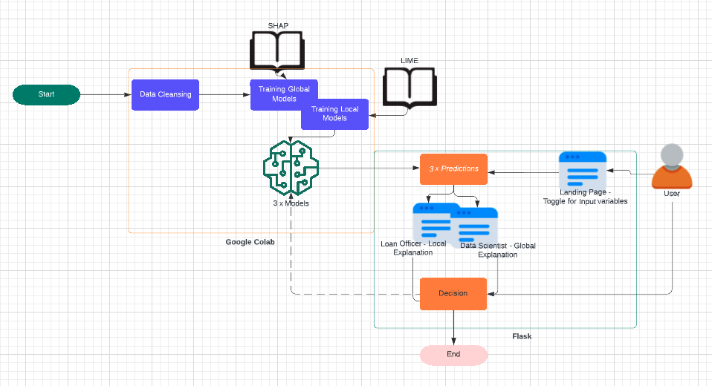
Figure 1: Product Design
The product uses three models (XGBoost, SVM and Decision Trees) pre-trained on FICO data. Upon fitting, these models had similar accuracy. The (pre-trained) models are then used to provide a row of predictions on a single row of data i.e. loan applicant’s details as feature inputs, as well as explainable and exportable justifications (using the SHAP and LIME libraries) for the predictions of each model. In the future, the end user’s override of the model predictions (Decision step), which would feed back (dotted line) into each of the models to further improve accuracy of the classifications.

4. Methodology
As summarized in the previous section, the product’s objective is to use cleansed data to train three algorithms and produce explainable results for each new loan application. These results needed to be displayed on screen to an appropriate audience.
For development we decided to separate the team into subgroups, one responsible for ‘back end’ model development, the other for ‘front end’ display of explainable predictions. The sub-sections below provide detail on the methodology used for both ‘model and front end’ development.

4.1 Data explanation
The training dataset i.e. Home Equity Line of Credit (HELOC) data originally comes from Explainable Machine Learning Challenge organized by FICO company. It consists of 23 predictors, 1 predictive feature and 10459 observations. Most features are monotonically decreasing or increasing. There are 5000 of which belong to class ‘Good’, and 5459 belong to class ‘Bad’. The features used and their description is summarized in Table 1 below:
Features | Description
ExternalRiskEstimate | Consolidated indicator of risk markers (equivalent of polish BIK’s rate)
MSinceOldestTradeOpen | Number of months that have elapsed since first trade
MSinceMostRecentTradeOpen | Number of months that have elapsed since last opened trade
AverageMInFile | Average months in file
NumSatisfactoryTrades | Number of satisfactory trades
NumTrades60Ever2DerogPubRec | Number of trades which are more than 60 past due
NumTrades90Ever2DerogPubRec | Number of trades which are more than 90 past due
PercentTradesNeverDelq | Percent of trades, that were not delinquent
MSinceMostRecentDelq | Number of months that have elapsed since last delinquent trade
MaxDelq2PublicRecLast12M | The longest delinquency period in last 12 months
MaxDelqEver | The longest delinquency period
NumTotalTrades | Total number of trades
NumTradesOpeninLast12M | Number of trades opened in last 12 months
PercentInstallTrades | Percent of instalments trades
MSinceMostRecentInqexcl7days | Months since last inquiry (excluding last 7 days)
NumInqLast6M | Number of inquiries in last 6 months
NumInqLast6Mexcl7days | Number of inquiries in last 6 months (excluding last 7 days)
NetFractionRevolvingBurden | Revolving balance divided by credit limit
NetFractionInstallBurden | Instalment balance divided by original loan amount
NumRevolvingTradesWBalance | Number of revolving trades with balance
NumInstallTradesWBalance | Number of instalment trades with balance
NumBank2NatlTradesWHighUtilization | Number of trades with high utilization ratio (credit utilization ratio - the amount of a credit card balance compared to the credit limit)
PercentTradesWBalance | Percent of trades with balance
RiskPerformance | Outcome of loan application
Table 1: Data Description

Exploratory Data Analysis:
We then inspected the correlation (if any) between the variables available in the dataset. The correlation matrix as well as a statistical summary of the features is provided in Figure 2 and Table 3 below:
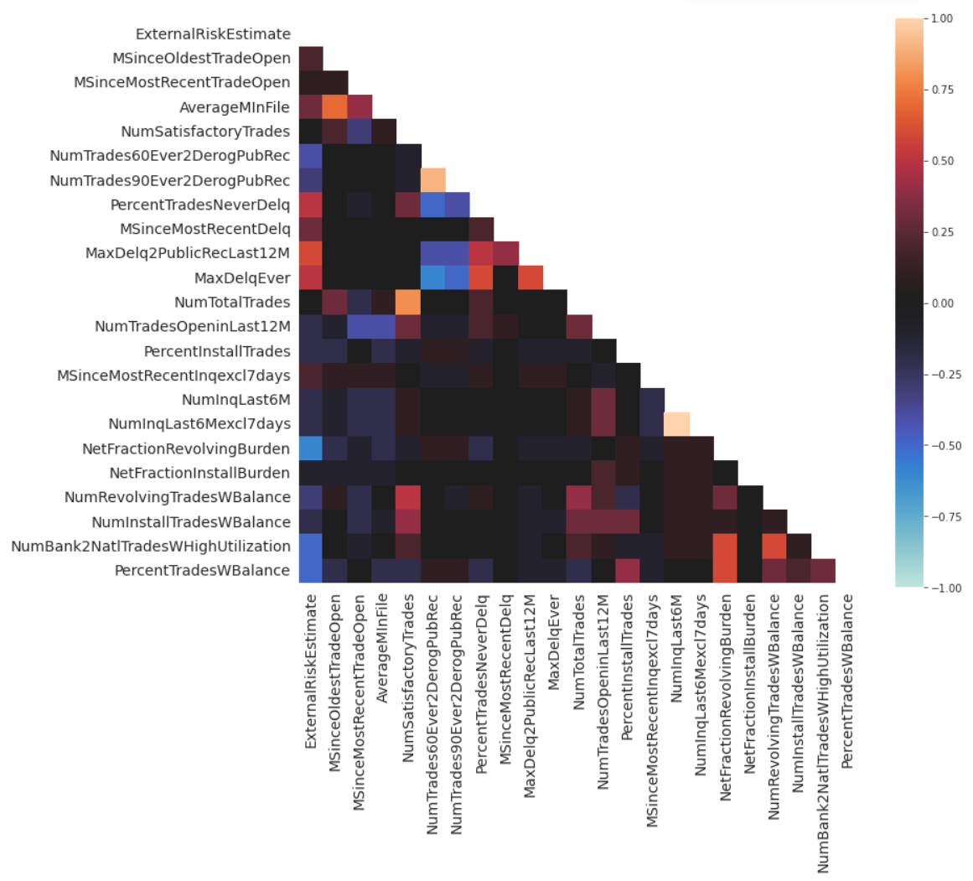
Figure 2: Heat Map of Correlation
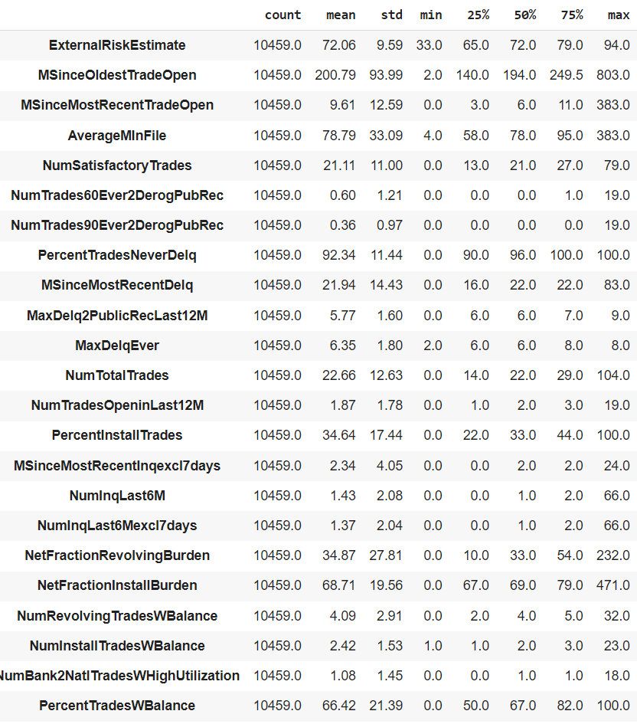
Table 2: Statistics Summary

4.2. Data Pre-processing:
Upon inspecting the data, we decided to use all elements as features to the three models. However prior to model training the data was pre-processed for error detection and encoding. Then the data was split for training and testing.

4.2.1 Error Detection
There are many negative values that occur in most features. These special values will be replaced by the mean.
- 9 : No Bureau Record or No Investigation
- 8 : No Usable/Valid Trades or Inquiries
- 7: Condition not Met (e.g. No Inquiries, No Delinquencies)

4.2.2. Encoding
The predictive feature, RiskPerformance has nominal data type. It will be encoded into binary where “bad” is 1 and “good” is 0.

4.2.3. Splitting Data
Data is split with a 70:30 ratio using stratification and the training set is further split by 10-fold cross validation.

4.3. Classification
The section below provides the methodology for model training, justification for the reasons why these specific models used for training as well as references to supporting literature.

4.3.1. Extreme Gradient Boosting (XGBoost)
There are many previous researches that used XGBoost to build classification models to predict the loan payment ability of applicants, resulting in high accuracies [1]. The performance of previous built models inspire us to reproduce a model that has comparable performance to classify whether the Heloc applicant gets approved or denied. XGBoost is a popular and efficient classifier that implements the gradient boosted trees algorithm to make predictions [2]. Gradient boosting attempts to accurately predict the target variable by combining the estimate of a set of simpler, weaker models to minimise the loss of new models [3]. To optimise the model perfomance, we employed the Grid Search technique for the hyperparameters tuning. We used logistic regression for objective and fine tuning {seed, col_smaple_bytree, learning_rate, max_depth, n_estimators and alpha} with all the avaiable features.

4.3.2. Decision Tree (DT)
Decision Tree algorithm is generated by splitting the data space into sections and producing decision rules to come up with a prediction. Basically, it has a flowchart structure, data is split by branches, each variable has an internal node, and each leaf node represents the outcome. In this project, we implemented this tree-based algorithm to solve our two-class classification problems. This is because our DT model performed as strongly as other methods like Random Forest or Extreme Gradient Boosting from the literature. This means DT was implemented as one of the best classification techniques to perform credit scoring on our HELOC dataset.
The most important parameter that impacts our DT model in terms of over-fitting and under-fitting is max_leaf_node. It is a specified number of leaf nodes based on reduction in impurity of a tree structure. In this case, the number of max_leaf_node was limited between 10 to 23. Other parameters tuning for this DT model are entropy criterion, default values of max_depth, max_features, min_samples_leaf, min_weight_fraction_leaf and splitter.

4.3.3. Support Vector Machine (SVM)
Support Vector Machine [4] algorithm implements the idea that training data are projected to a high-dimension space, hyperplanes are created to separate these data points with different classes, and the optimal hyperplane is the one with the maximum shortest distance to the data points.
One of the advantages for SVM is that, unlike algorithms like neural networks who use gradient descent optimization, it uses convex optimization to find the hyperplane, so it will not be stuck in the local minima and its solution is always global minimum [5].
The parameter tuned for our SVM is the type of kernel functions. A kernel function is used to map the training data to a high-dimension space. The options for kernel functions can be ‘linear’, ‘ploy’, ‘rbf’, ‘sigmoid’, etc. A simple grid search is carried out and the accuracy of the model achieves highest when choosing ‘rbf’ as the kernel function.

4.4. Explainable AI
Upon training the models, we utilized available ‘Explainable AI’ libraries that were going to be used to provide tailored explanations of the outcomes to the appropriate audience. Figure 3 below provides the complete overview for ‘back end’ model development.

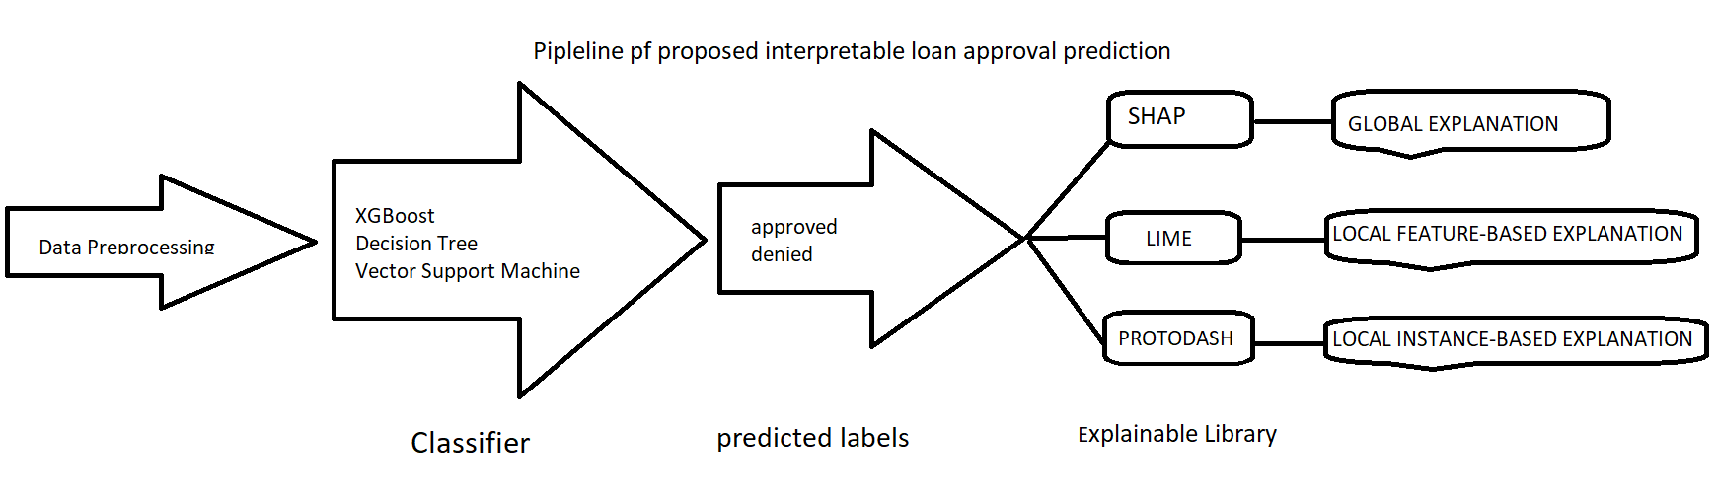
Figure 3: Summary of back-end development
Advanced ML methods are quickly adopted in the financial industry to transform large and complex data to predict credit scoring, loan approval, investment decision and so on. However, these AI learning techniques lack interpretability and transparent predictions. There is a cost associated with wrong decisions by AI applications. Thus, it is crucial to understand how the model behaves and makes a decision.
As the target users of this project are rejected loan applicants, loan officers and data scientists, it is important that there are different explanations tailored for these target audiences.
Users | Library | Level of Explanation
Rejected loan applicants | PROTODASH | Local feature-based
Loan officers | LIME | Local instance-based
Data scientists | SHAP | Global
Table 3: Target users for each level of explanation

4.4.1. Global Explanation
Global explanations provide overall understanding on how the classification models work. The general logic behind the decision-making process is interpreted through these explanations [6]. This level of explanation is preferred by the data scientist and regulators to ensure the correctness, fairness, and compliance of the models in predicting a loan approval prediction.
In this project we employed SHAP to provide the model’s global explanations. Based on these above classification models, the explainers are created to generate SHAP values for each feature for each prediction then average the absolute SHAP values per feature. Features with large absolute values SHAP values are important. To inspect the importance and impact of features toward the model prediction, we use SHAP summary plot.

4.4.2. Local instance-based
Local instance-based explanations attempt to interpret individual predictions but focus more on finding similarities between an unseen instance and existing instances in the dataset. For example, if our model’s prediction for a new applicant is classified as approval, we would like to see how this applicant is similar to the existing clients in our dataset who manage to repay the loan without default. By looking at several similar clients, we might get a sense on whether the model’s prediction can be justified.
In our application, the ProtoDash method by AIX360 python library is used to provide instance-based explanations [7]. ProtoDash can evaluate the similarity between the new application and the existing data, order the instances based on each instance’s importance weight, and return the instances with the highest weights. In our application, 3 most similar instances are provided as the final instance-based explanations.

4.4.3. Local feature-based
Local feature-based explanations describe the local understanding of the reasons a specific prediction was generated. In this project, the local feature-based explanations are generated using Local Interpretable Model-agnostic Explanations (LIME). LIME is a method to explain machine learning predictions. This is important because explaining the prediction reinforces trust in the prediction [8]. If users don’t trust the prediction or model, then they will not use it. Particularly when predictions are used in high-risk decisions. To achieve this, LIME takes black box machine learning models as input; and generates explanations about contributions of each feature in making a decision on individual data observations [9].
There are three modules of LIME that can be used to generate explanations: lime_tabular; lime text; and lime image. In this project, we used module lime_tabular to generate explanations because our dataset is structured. The following steps explain how LIME works in our project [10].
- It takes an observation, generates a fake dataset based on it, then permutes the fake dataset.
- Calculate similarity metrics between permuted fake data and original observations.
- Make a prediction on the new permuted fake data using our original complex model.
- Pick features that best describe our complex model's performance on permuted fake data. The lime library lets us provide how many features to pick up.
- Fit simple model on the combination of permuted fake data with selected m features and similarity scores computed in earlier steps. The lime library lets us provide a simple model that we want to use. Generally, it's linear regression or logistic regression but we can change it.
- Use weights derived from that simple model for each feature to explain how each feature contributed to making a prediction for that sample when predicted using an original complex model.
In summary, LIME generates fake data using our dummy dataset, trains a simple ML model which has the same performance as our complex black-box model, and uses this model's weights to describe features' importance [10].

4.5. Front-end Development
In the effort to produce a Minimal Viable Product, we used Python Flask as our web framework for rapid development. By design, Flask is quite easy to use and quick to set up, which fits our purpose – to get a visualization/concept up as fast as possible. It is also a matter of convenience as all the backend development is also done in Python, eliminating the need for APIs (application program interfaces) for cross-language development.

5. Findings
This section provides detailed results on model performance upon training.

5.1. Model Performance:
Classifier | The best parameters | Accuracy | ROC_AUC
XGBoost | {seed:70, col_sample_bytree=0.4, learning_rate=0.01, max_depth=5, n_estimators=500, alpha=10} | 0.73 | 0.725
DT | {max_leaf_nodes = 15, random_state=0, criterion='entropy',min_samples_split=2, splitter='best', min_samples_leaf=1, min_weight_fraction_leaf=0.0} | 0.70 | 0.70
SVM | {kernel='rbf', probability=True} | 0.72 | 0.71
Table 4: Summary of model performance
The best results in papers are around 0.8 AUC using XGBoost [11], while our model based on XGBoost has 0.725 AUC. The performances of our decision tree and Support Vector Machine are compatible to the models in [7].

5.2. Global Explanation
The figures below provide an overview of the Global Explanation, which is targeted for use by data scientist to obtain a ‘global’ understanding of features driving predictions.
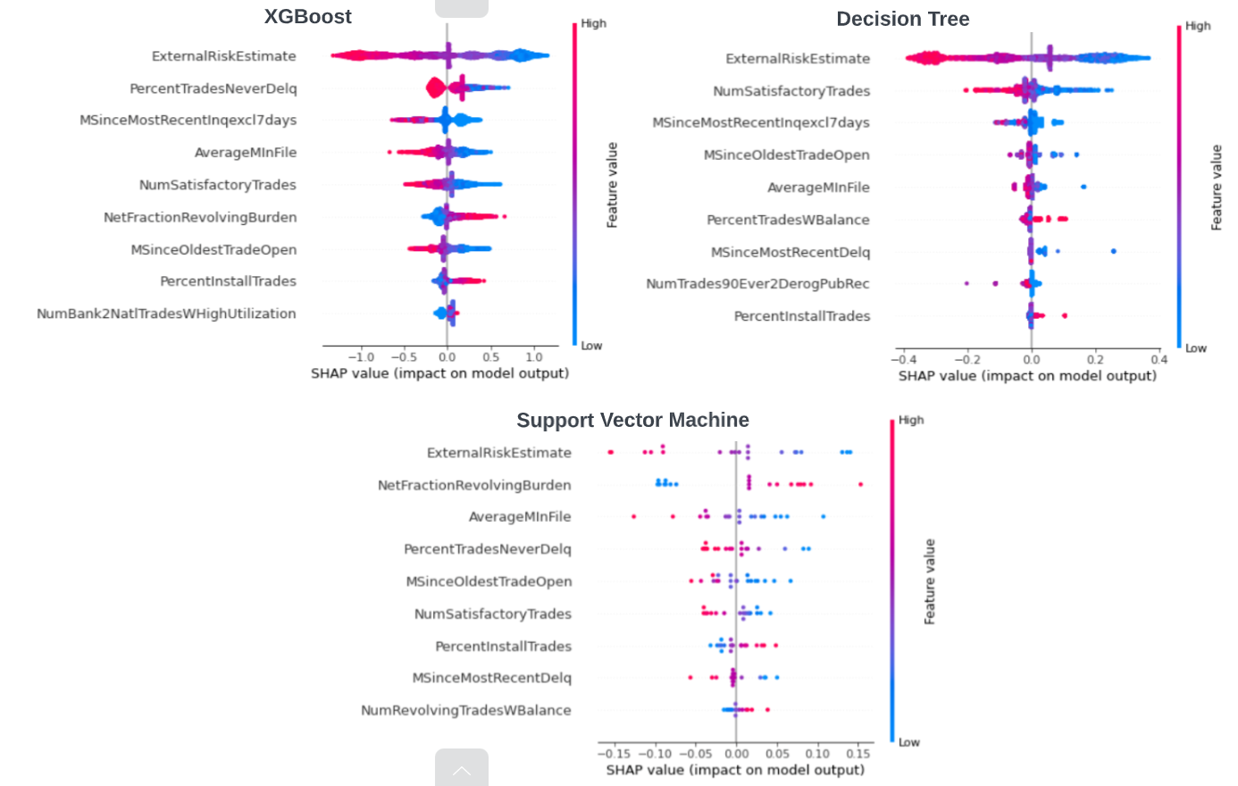
Figure 4: Global explanation by SHAP
According to the above figure, ExternalRiskEstimates, AverageMinFile, MSinceOldestTradeOpen, PercentinstallTrades and number of satisfactory trades always occurred in the top 9 of all build models. External Risk Estimates is the most important feature as it is a top 1 importance feature in all built models. Besides that, Net Fraction Revolving Burden,
Percent Trades Never Delq and MSinceMostRecenttinqexcl7days also appeared twice in the top 9 important features across three models. Low values of External Risk Estimate results in high SHAP values which push the prediction toward the denied (class 1) whereas high values of External Risk Estimate results in low SHAP values which push the prediction toward the approved (class 0). Moreover, a smaller NumSatisfactoryTrades leads or a smaller MSinceOldestTradeOpen lead to a higher chance of the application getting denied. These observations are inline with the monotonicity constraints of the HELOC dataset. The global explanations are consistent across all three models which indicates that the global explanations provided for these models by SHAP are reliable and logical.

5.3. Local instance-based
We also created local instance-based explanations in the form of displaying a selection of instances from the training data who are similar to the new applicant. The underlying assumption is that new applicants sharing similar features with existing clients might end up in the same situation.
One example explanation generated by ProtoDash is shown in figure 5. The user input column shows the features for the new applicant (test data from holdout set) who has been classified as ‘deline’ by our model. The other 3 columns show the features for the existing clients who fail to repay the loan. Those highlighted values are within 20% deviation from the new applicants’.
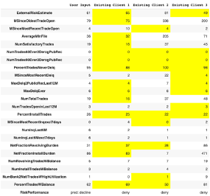
Figure 5: Explanation generated by ProtoDash

5.4. Local feature-based
Continuing with local explanations, an example of how LIME interprets prediction on the first observation of the Decision Tree model is shown in feature 3. This output is from the prediction on the first observation of the test dataset. We used the explain_instance() method on the explainer object. We referenced to predict_proba () method of the DT model to generate an explanation object for this observation. We then used show_in_notebook() method on the explanation object to generate HTML of explanation.
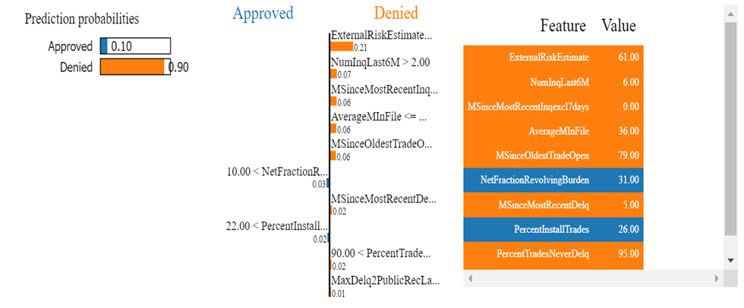
Figure 6: Visualisation of feature contributions as HTML
In figure 6, the visualisation has a progress bar, a bar chart, and a table. The progress bar shows prediction probabilities where value varies and actual prediction. The bar chart shows features that contributed positively and negatively to prediction. This bar chart is sorted in descending order of feature importance and showing weights of how features contributed to this prediction. The table shows actual features contributions. In this case, only 10% predict ‘Approved’ based on NetFractionInsatllBurden and PercentInstallTrades while 90% predict ‘Denied’ based on other features.

6. Impact and Significance of Results
The product provides explainable machine learning backed automation and explanation of loan approvals for lenders. A few examples of how the product can be used are listed below:

- It can be integrated into the current lending process and can be tune for semi to full automation of loan approvals given acceptable levels of accuracy.
- The product also has use in compliance to answer queries from regulators.
- The product can also be used for responses to customer complaints in case of application denials and what can be done to improve
The impact of this significant as the total time required for current lending processes that typically take days or weeks to review could be reduced significantly (to hours). The product will also ensure audit trails are maintained (with explanations) in case of regulatory or customer requested review.

7. Project Management
This section details our project management methodology. Due to the rapid product development requirements of this assignment, this project was managed using a combination of lean and Agile SCRUM methodology.
In the very first team meeting, all members described their strengths and weaknesses and what they would like to focus on in the project. The following table provides roles, responsibilities, and contributions of each team member:
Student ID | Full Name | Roles/Skills/Strengths | % Contribution
s3888673 | Oliver Southon | Front end development & visualisations of charts & Presentation | 16.66%
s3828276 | Ngoc (Vy) Bao Le | Research / Analysis & Model building & Model explanation | 16.66%
s3888611 | Zhen Qian | Research / Analysis & Model building | 16.66%
s3829607 | Yahua (Frank) Fan | Research & Model building & Presentation | 16.66%
s3864915 | Adnan (Sami) Ahmed | Project Management, & Research Model building & Presentation | 16.66%
s3651761 | Linda Nguyen | Model building & Model explanation & Visualisation | 16.66%
Table 5: Information of team members
The first two weeks of the project, which were used to research current ‘explainable’ AI technology particularly related to HELOC loan approval problem. All team members were involved in research and at the end of the two-week window, team members presented their summary of research. The session, which also used to brainstorm what our product would look like and the value that would be added by the product. As such, we chose to implement three explainable classification models as well as a choice to override the model predictions – something that we had not seen in our research.
Upon completion of research, our intent was to develop a prototype that includes core product functionalities in the limited time available. A timeline was developed to include four sprints that would allow us to develop the prototype of the product (back end and front-end development) and meet the requirements of the assignment (oral presentation and report). The timeline is shown in Figure 8 below:
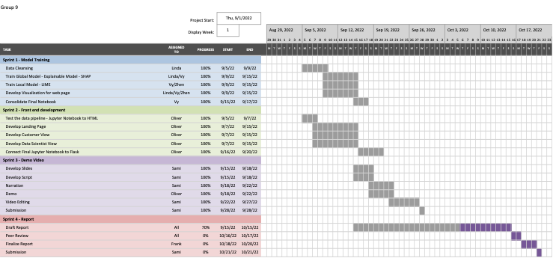
Figure 8: Work progress
We used MS Teams and a OneNote site that is linked to MS teams as our primary project management tool. A sample of the OneNote tool is present in the screenshot below:
Figure 7: Team Meeting management
The team connected once each week, we also connected with our mentor once each week. All team meetings were recorded and included a pseudo-Kanban board tracked via an agenda, status with meeting notes as well as next steps (with each step being assigned to a specific person who would be accountable for delivery by a specified period within the sprint).
As we began development, per Figure 9 below, all files related to development were kept in the google cloud and we selected Google Collab for backend development, which was then connected to html documents in a Flask environment. Upon completion, all files and folders were moved to GitHub.
Figure 9: Link to files and folders
Canva was used for developing oral presentations, due to its slick and user-friendly interface and outputs. Link 1 below navigates to the oral presentation:
https://www.youtube.com/watch?v=c3FPShAms3s
Link 1 – Oral Submission
Ultimately, using the tools above and the unique skillset and equal contribution of each team member we were able to deliver this project in a timely manner.

8. Ethical consideration
The Ethical concern in our case is like the traditional HELOC loan application hence our excise, which just to automate the HELOC loan application process. Therefore, in the broadest sense, the ethics concern in lending still means treating everyone equally, being honest in all situations and given full disclosure without being prompt during the loan application and from the loan approval respective, that do not take the advantage of people.
Traditionally, loans and mortgages were obtained from local banks. If someone wanted to buy a house, they just walked into the bank and met with the banker who they knew on a personal basis. Because this banker knows the client and holds the load on his balance sheet. He had a solid interest in making sure that he approval the loan amount that would set them up for success while in our case everything is done through data analysis, regardless of who the borrower is, and only trade this like normal transaction. E.g., no emotions are involved. In addition, in the worst-case scenario that will started giving out loans to people who were not qualified which is part of the reason we saw a massive housing collapse at the end of last decade.
To mitigate and make our product more ethical and profitable. We recommend ethical should be shown and not just said by the user, E.g., our product which more like tools that to assist the loan offer that to make decision and the loan applicant who using our product to apply for the loan. In this case, that specific action steps that user of our product require to fulfill their obligation to be ethical and responsible. We have done a quick summary as per the following:
- Educate Borrowers
- Promote individual Accountability
- Take Confidentiality Seriously

8. Conclusion & Future Development
At its current state, the only level of interaction that lies between the front-end users and the machine learning algorithms is running predictions. This is satisfactory, but in today’s industry standard, models are often dynamically trained with user input. To incorporate this into our project, we wish to give users the option to ‘disagree’ with the decision of a model, overwriting its prediction. This result will be saved and feed back into the model itself, hence further training it. We believe this adds a higher correspondence between the users’ goal of this product and the outputs it predicts.
In addition, another bottleneck of our product is that its slug size is extremely large, at ~3GB. This means the performance is slow and it is too sizeable for deployment (Heroku’s limit is 500MB). Even after attempting to painstakingly deploy, it as a Docker container, we still had no luck. The usage of TensorFlow, Lime, and Shap contribute to about 75-80% of the size. For a web application, this is poorly optimized as is. In future development, one of our main targets would be to boost the performance of the app itself, and switch to a framework that is more suitable for deployment (which would require funding).
Lastly, from an intuitive User Interface point of view, it is also on our list to make the home page easier to navigate. Instead of having all features listed on the screen, that can be broken up with pagination, and having a dropdown box for a description for each. To increase flexibility, we would also seek to add an option to enter pre-existing data (e.g.: a CSV or txt file) as the feature parameters.

References
[1] Demajo. L, Vella.L and Dingli. A, Explainable AI for Interpretable Credit Scoring, 2020, Department of Artificial Intelligence, University of Malta, Msida, Malta, pp. 185-203. [Online]. Available: https://arxiv.org/ftp/arxiv/papers/2012/2012.03749.pdf
[2] Interpretable Machine Learning with Xgboost, Towards Data Science, Retrieved 5th October 2022 <https://towardsdatascience.com/interpretable-machine-learning-with-xgboost-9ec80d148d27>
[3] Dutta.S , Long.J , Mishra.S , Tilli.C and Magazzeni.D, 2022, Robust Counterfactual Explanations for Tree-Based Ensembles, Proceedings of the 39th International Conference on Machine Learning, vol. 162, pp.5742-5756.
[4] C. Cortes and V. Vapnik, "Support-vector networks", Machine Learning, vol. 20, no. 3, pp. 273-297, 1995. Available: 10.1007/bf00994018.
[5] "SVM : Advantages Disadvantages and Applications", Statinfer, 2022. [Online]. Available: https://statinfer.com/204-6-8-svm-advantages-disadvantages-applications/. [Accessed: 08- Oct- 2022].
[6] Chen.C, Lin.K, Rudin.C, Shaposhnik.Y, Wang.S and Wang.T, 2018, An Interpretable Model with Globally Consistent Explanations for Credit Risk, Retrieved 5th October 2022 <https://users.cs.duke.edu/~cynthia/docs/ChenEtAlFICO2018.pdf >
[7] V. Arya et al., "One Explanation Does Not Fit All: A Toolkit and Taxonomy of AI Explainability Techniques", arXiv.org, 2022. [Online]. Available: https://arxiv.org/abs/1909.03012. [Accessed: 08- Oct- 2022].
[8] X. E. Asuncion, "Understanding machine learning predictions with LIME," 2021. [Online]. Available: https://medium.com/@ginoasuncion/understanding-machine-learning-predictions-with-lime-7892998c7484.
[9] G. Visani, "LIME: explain Machine Learning predictions," 2020. [Online]. Available: https://towardsdatascience.com/lime-explain-machine-learning-predictions-af8f18189bfe.
[10] S. Solanki, "How to Use LIME to Interpret Predictions of ML Models?," 2022. [Online]. Available: https://coderzcolumn.com/tutorials/machine-learning/how-to-use-lime-to-understand-sklearn-models-predictions.
[11] Heloc Credits, XAI Stories, Case Study For Explainable Artificial Intelligence, Retrieved 5th October 2022 < https://pbiecek.github.io/xai_stories/heloc-credits.html>

